13 September 2024 (Friday the 13th!) postcard

Night before last we got in pretty late, and I got up early for the market, so this morning, I slept in to catch up a little. The breakfast room was much calmer at 9:15 am than at 8 am!

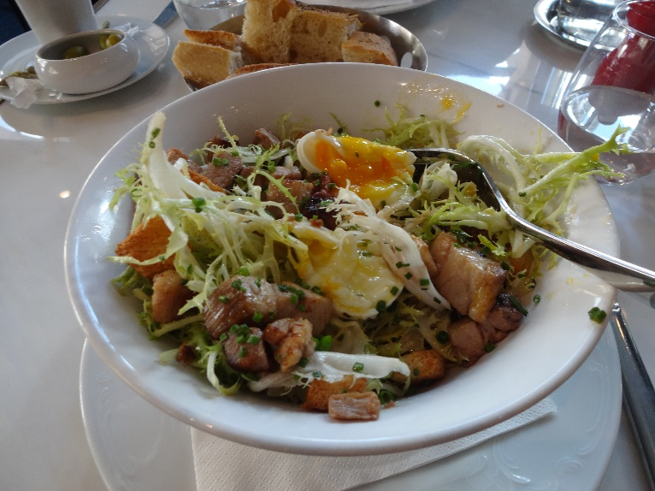Our excursion today was to the Louvre, 2 pm admission, so when David appeared as usual about 11:30 am, we headed for the metro at Bastille and caught the good old #1 line to Palais Royale, just one stop farther than Louvre-Rivoli, where we got off for our dinner at La Régalade on Tuesday. Last night's dinner was so over the top, and tonight's promised to be as well, that we really wanted only a light lunch. "Chef of the Century" Paul Bocuse of Lyon has authorized the chef at the Brasserie du Louvre (the restaurant of the Hotel du Louvre), just a few steps from the museum, to recreate some of his classic dishes and to call the place a Brasserie Bocuse. We'd had dessert there once but never a meal, so we gave it a try. The hostess gave us rather a disapproving look for not having a reservation, but she seated us anyway. We chose only from the starters on the menu; we both had the "salade Lyonnaise," consisting of frisée lettuce, lardons, croutons, and a poached egg. I then followed up with six snails in very hot garlic-parsley butter. The salad was great: the frisée was very frisée, almost prickly it was so curly and crisp, the vinaigrette was superb, the croutons crisp and tender, the lardons not so much crispy fried bacon strips as extremely tender and succulent cubes of braised pork belly, and the egg not only perfectly poached but perfectly egg-shaped, not even slightly flattened!

The snails were also excellent, so garlicky, you could smell them coming from the kitchen. For dessert, we split a "sablé aux fraise," a tender shortbread cookie topped with vanilla cream, sliced strawberries, and a mint-basil pesto.

In preparation, I had mapped out the sections of the Louvre we wanted to see: (1) the Orientalists (à propos of the immersive show we'd just seen), (2) the Dutch old masters, and (3) the masterpieces of the Torlonia collection on load from someplace in Italy I think. As it happens they had a ton of Orientalists, so we never even made it out of that section! Because it's on the top floor and not in the same wing as the big three (Venus, Vicky, and Mona), it was much less crowded than the areas we passed through to get there and then out again. So far all the museums have had free lockers for hats, coats, and whatnot. Now if they just had those little folding stools the German museums have . . .

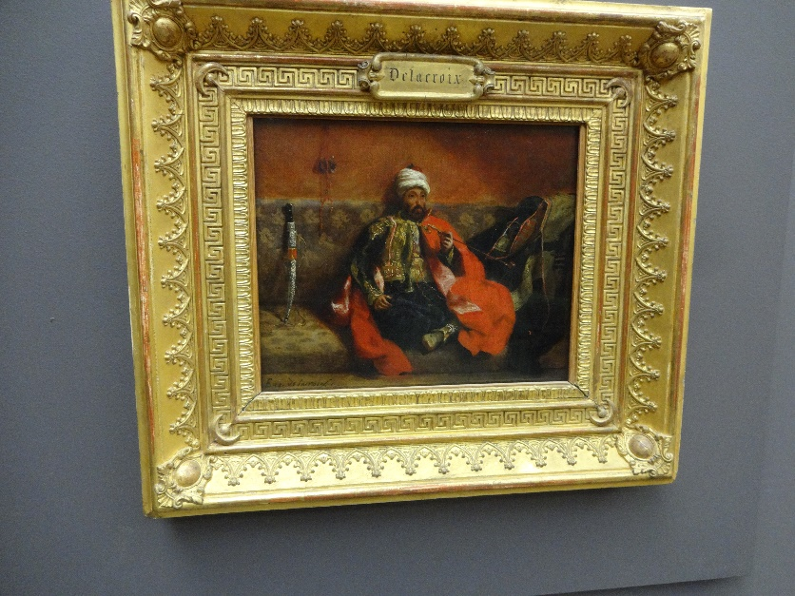Here's a Delacroix of a Turc sitting on a divan and smoking.

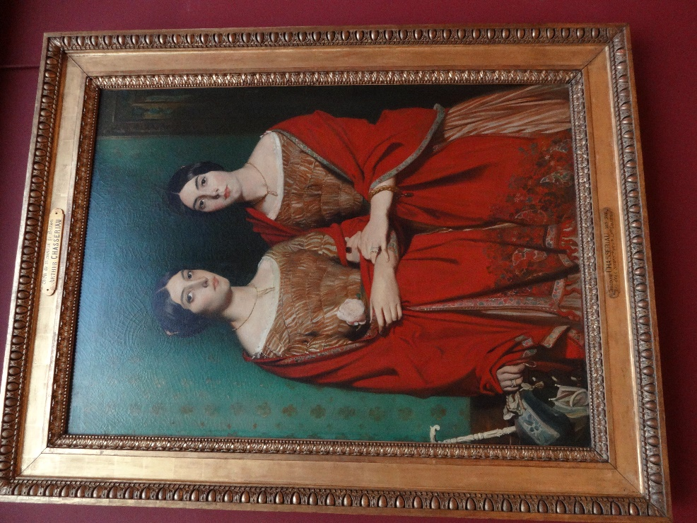

And a Chassériau portrait of his two sisters that appeared prominently in the immersive show at the Atelier des Lumières.

Supper was our third visit to Restaurant David Toutain, near the explanade of the Invalides. His food is great, but he, too, tends to offer a 9-course tasting menu and then to bring you 12 to 15 courses.

On this occasion we chose the 10-course tasting menu, which started with four amuse bouches before we even started. Then we got seven savory courses (interspersed with three different bread services, each with a different butter), a cheese course, and three desserts, plus mignardises. All superb.

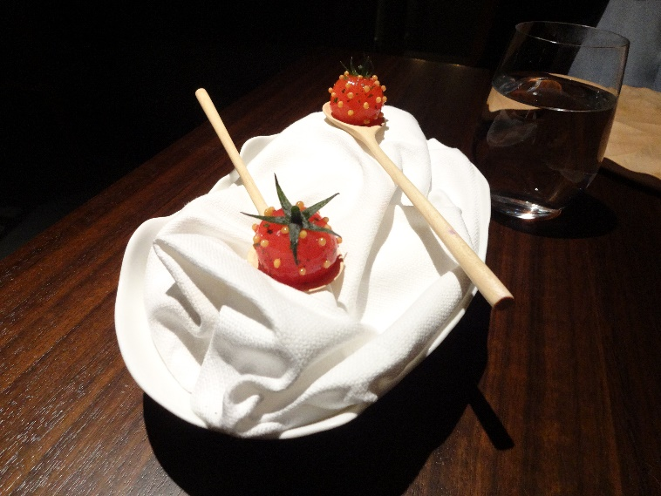Here's one of the amuse bouches: for each of us, an heirloom cherry tomato peeled, poached, stuffed (from the bottom) with a preparation of cow parsnip (*Heracleum sphondylium*), and painstakingly studded with tiny poached yellow mustard seeds. Scrumptious! The waitress specified that the green calyx was decorative only and not meant to be eaten.

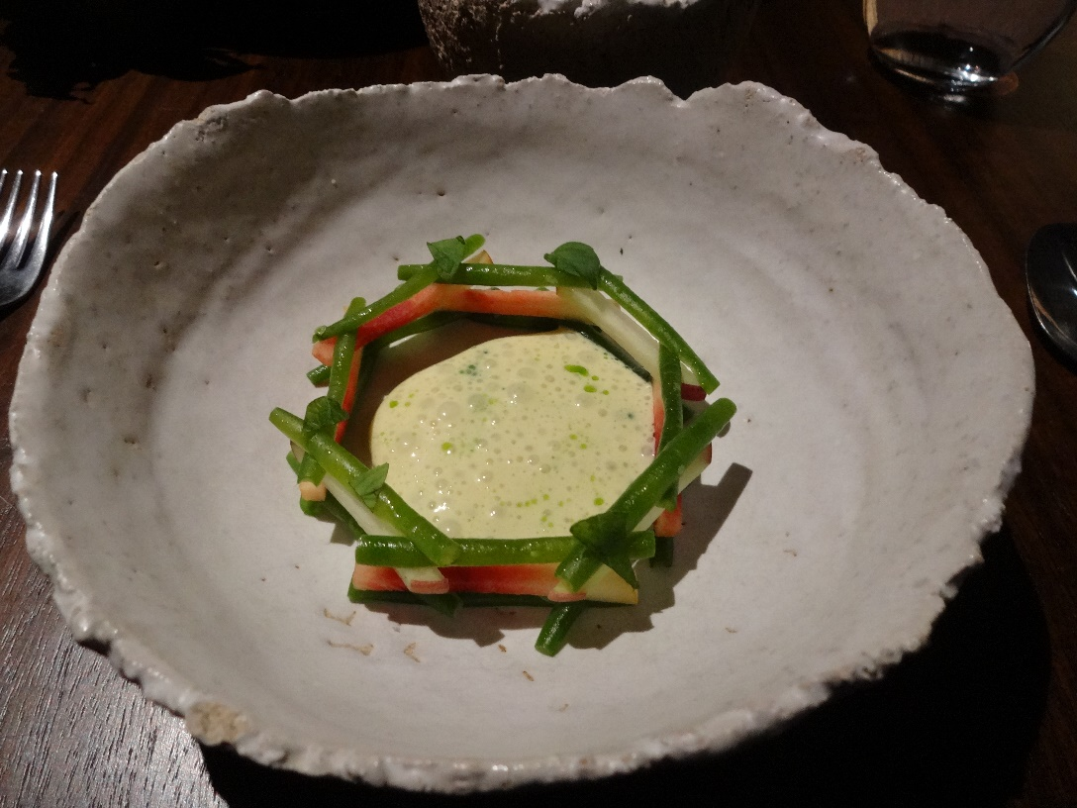And here is one component of one of the actual courses: an equally painstakingly assembled "log-cabin" made of tiny crispy green beans and tiny batons of fresh peach made to contain an emulsion of fig leaves. Odd sounding, but incredibly delicious!